**District VII**

Playing Program

Spring League 2020

**For more information**:

• Speak to your League

• Visit District VII website

(cysadistrict7.org)

• Email CYSA D7 office (cysad7office@gmail.com)

• Email Playing Program (district7pp@gmail.com)

Register through your League

**Spring League applications are now open**

Deadline for applications - **February 1st 2020**

Spring League begins March 7th 2020

All age brackets from U10—U19 *Rec & Adv*

(CYSA Registered teams only)

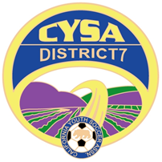

***Fees:*** *U10 $375,*

*U12 $400,*

*U14 — U19 $425*