California Youth Soccer Association, District VII
4285 N. First Street
Fresno, Ca 93726
Phone: 559-227-CYSA(2972)
Fax: 559-227-CYSA(2972)
Email:cysad7office@gmail.com
Web: www.cysadistrict7.org

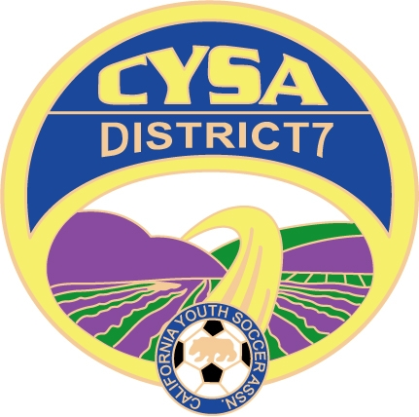

MAY 2017

To: All Leagues

From: John Hodgson, District Commissioner

Re: D7 Fall Playing League information to include San Joaquin Valley Playing League Recreation and Competitive Divisions, plus Cal North CCSL and CRL playing Leagues.

For 2017-18 CYSA/Cal North soccer season, those Leagues wishing to participate in the District wide “Playing League” please fill out the attached application form and forward with the appropriate fee and copy of roster to:

District VII Office, 4285 N. First St., Fresno, CA 93726

Listed below are the age groups eligible to play in the district wide league: Teams that use tryouts need to be registered as competitive.

In the Competitive Age Groups, we will offer 2 groups of play as approved by the District VII Board;
- The Qualifier teams will play 3 matches in the appropriate age group, this will allow eligibility for Cal North Cups and Sanctioned tournament play with US Soccer Affiliates.
- League Play, This group will play a more traditional League play of up to 7 matches, Coaches and Teams will schedule their matches with flexibility of scheduling in the District system.

In the Recreational Division there will be 9 to 10 matches played to a set schedule with limited scheduling changes allowed after the “24 hour window” .

Teams wishing to play in the State CCSL or CRL leagues, must be Registered in a District 7 League and pay all League, District and State Fees.

2017/18 Fall Team Fee Schedule:

Competitive Qualifier Division U10 - U19 ………. $250.00 ……. (3 matches)
Competitive League Division U10 - U19 ………. $450.00 ……. (6-7 matches)

Recreation Division ………… U12 …………….. $375.00 ……. (9 to 10 matches)
Recreation Division ………….U14, U16 and U19 . $575.00 ……. (9 to 10 matches)

For CCSL and CRL D7 Admin Fee ……………… $150.00

Entry in to all Leagues will be considered acceptance of the rules.

DEADLINE: District 7 Playing League is July 15th, 2017 teams accepted after that will be on an “as needed basis”. Please submit Application, Fees and Roster to the D7 Office.

Deadlines for both CRL and CCSL are posted on the Cal North Website.

Rosters must contain the minimum number of players according to Cal North Registration protocol, once a team is accepted into the District 7 Playing League, any team withdrawing may forfeit their application fee.

